**Portable Braille Translator Device**

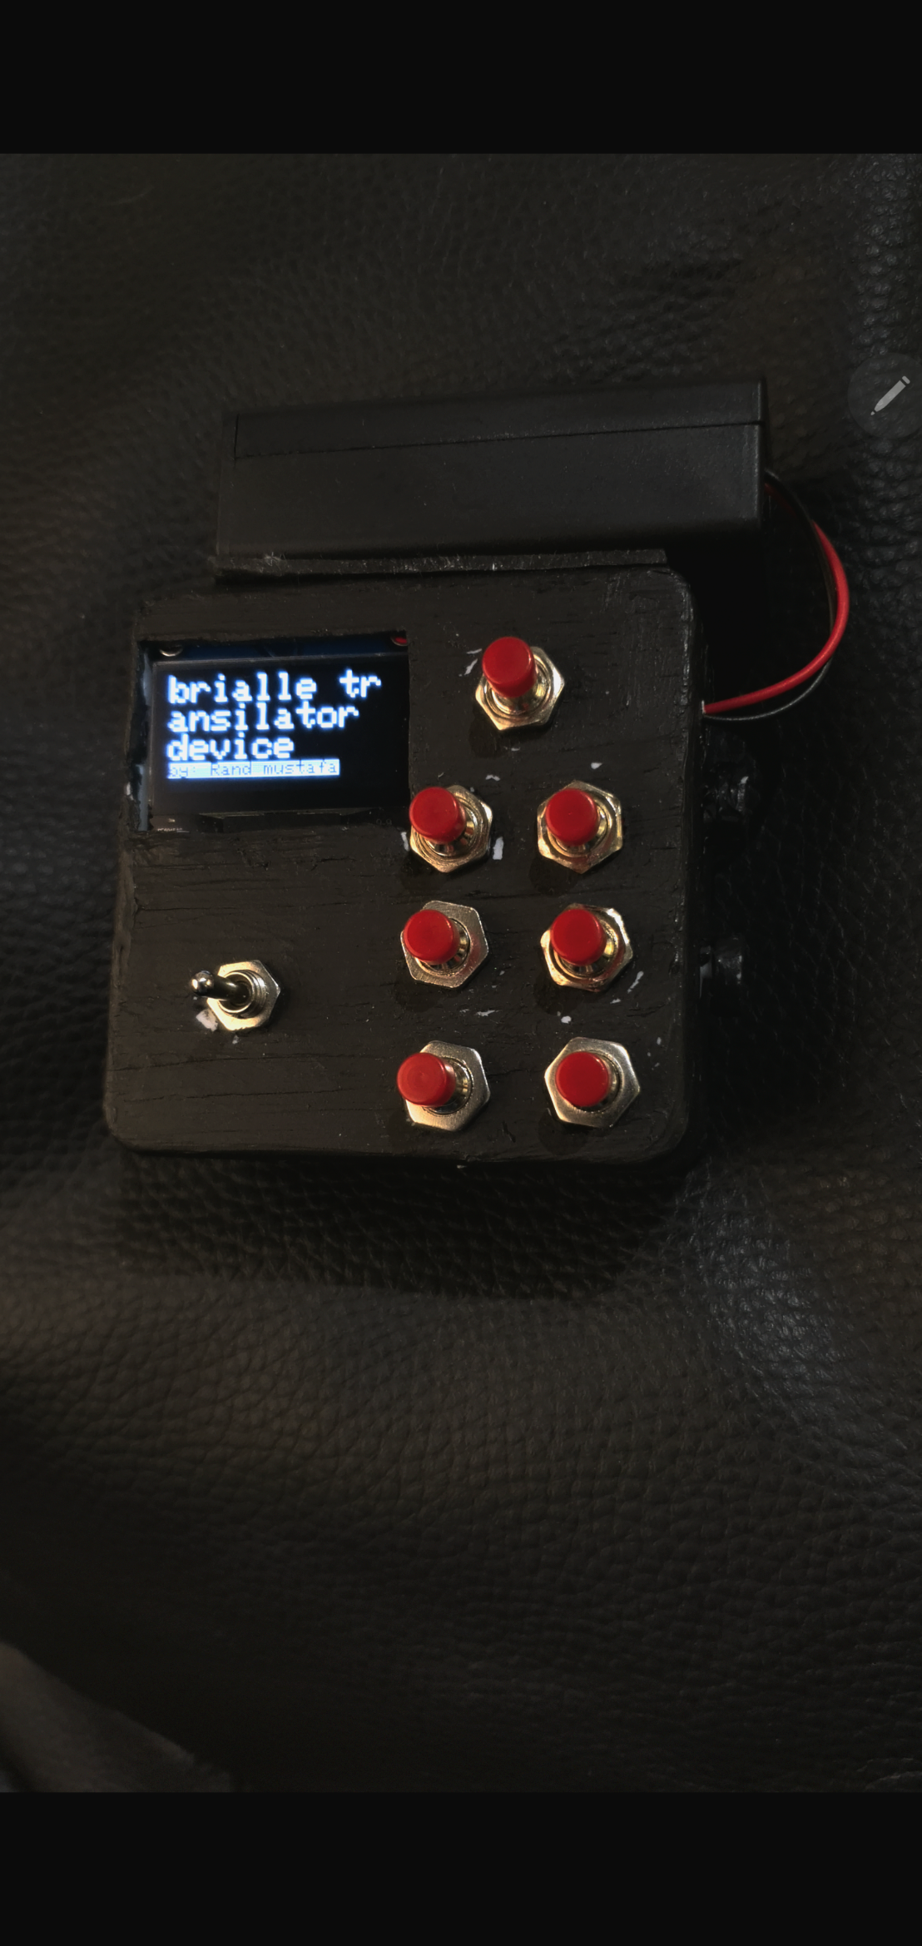

**By: Rand Mustafa AbdulKareem / third stage / 2023**

**Introduction:**

The Portable Braille Translator project aims to address the pressing need for enhanced accessibility among individuals with visual impairments. By developing a portable Braille translator device utilizing an OLED display and tactile buttons, the project seeks to empower users with real-time Braille translation. This initiative responds to the limited availability of affordable and portable Braille devices, ultimately enhancing independence and inclusivity for those with visual impairments. Recognizing the critical role of Braille as a tactile writing system, the project aligns with the broader mission of leveraging technology to foster a more inclusive society and improve the quality of life for individuals with disabilities.

this project is a pioneering effort to enhance accessibility by providing a portable and affordable solution for Braille translation. Through its innovative approach, the project contributes to the larger mission of using technology to break down barriers, ensuring that individuals with visual impairments can fully participate in and contribute to our increasingly digital society.

**Objectives:**

* **Develop Portable Braille Translator:** Create a compact, portable device for real-time Braille translation.
* **Real-Time Translation**: Enable instant conversion of digital text into Braille.
* **User-Friendly Interface:** Design an intuitive interface with tactile buttons and an OLED display.
* **Affordable and Accessible:** Keep the device cost-effective to enhance accessibility.
* Enhance Independence: Empower users with improved access to written information.
* **Promote Inclusivity:** Foster equal participation in education, work, and social interactions.
* **Utilize Modern Technologies:** Incorporate OLED display and tactile buttons for enhanced functionality.
* **Raise Awareness:** Advocate for the importance of Braille and accessibility.

**Hardware Setup:**

This device utilizes the following key hardware components:

* **Adafruit_SH1106G OLED Display:** A 128x64 pixels OLED display for presenting translated Braille characters.
* **Tactile Buttons:** seven tactile buttons for user input, each assigned to a specific Braille character.
* **rocker Button:** rocker switch that exchange from the characters mode to numbers mode
* **Microcontroller:** The hardware setup interfaces with a microcontroller, responsible for processing user inputs and controlling the OLED display.
* **Wiring and Connections:** The hardware components are connected using I2C communication protocol, with specific pin assignments to ensure proper functionality
* **resistors**

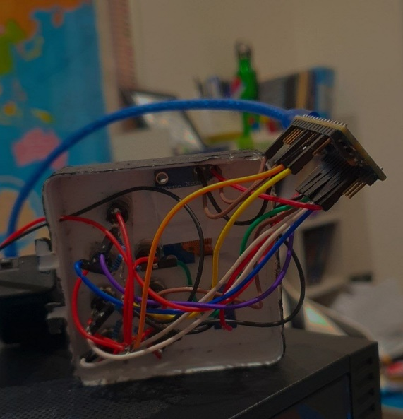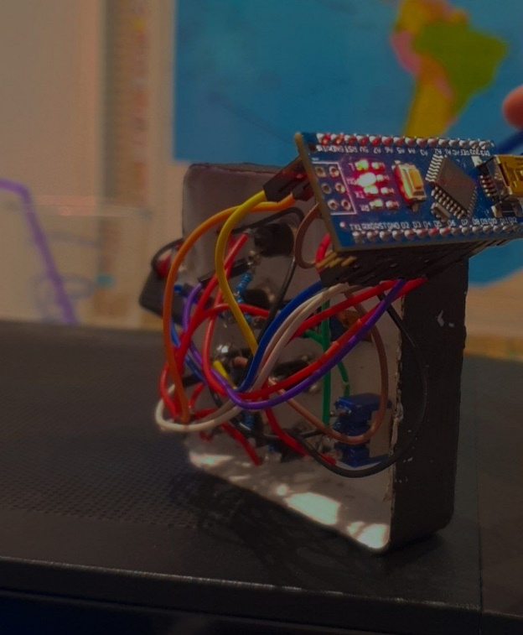

**Software Implementation:**

The software implementation of the Braille project project involves the following key elements:

* **Arduino IDE:** The project is programmed using the Arduino Integrated Development Environment (IDE), making it accessible for a wide range of developers.
* **Adafruit_SH1106 Library:** The Adafruit_SH1106 library is utilized for easy interfacing with the OLED display, simplifying the code for display control.
* **Button Input Handling:** The program uses the pinMode function to set the tactile buttons as inputs and employs digitalRead to detect button presses.
* **Braille Translation Logic:** Conditional statements are employed to determine the Braille character corresponding to the specific combination of button presses.
* **Display Control:** The display functions, such as setTextSize, setTextColor, and setCursor, are used to control the appearance of text on the OLED display.
* **Main program:** the main program that has the functions of translating the inputs from braille code to English alphabet

**Full code is available on my personal GitHub account**

**Conclusion:**

In conclusion, the Portable Braille Translator Device represents a significant stride towards enhancing accessibility and independence for individuals with visual impairments. The development of a portable Braille translator device, with real-time translation capabilities and a user-friendly interface, addresses the critical need for accessible tools in daily life.

The project's objectives, ranging from affordability and inclusivity to the utilization of modern technologies, have been successfully met. The device's hardware setup, incorporating an Adafruit_SH1106G OLED display and tactile buttons, showcases a well-thought-out design for optimal user interaction.

On the software front, the implementation in the Arduino IDE, coupled with the Adafruit_SH1106 library, ensures a straightforward and accessible programming environment. The logic for Braille translation and display control provides users with real-time feedback, confirming their input and presenting the corresponding Braille characters.

The Portable Braille Translator Device not only serves as a practical solution for individuals with visual impairments but also contributes to the larger conversation on inclusivity and the importance of accessible technology. By promoting awareness and encouraging further development, the project aims to have a lasting impact on the field of assistive technologies.

In essence, the Portable Braille Translator Device exemplifies the power of technology to bridge gaps and create opportunities for independence and equal participation, fostering a more inclusive and supportive environment for individuals with visual impairments.